**PROJECT REPORT**

**HOSPITAL MANAGEMENT SYSTEM**

**Course Code: CSE-3532**

**Course Title: Tools and Technologies for Internet Programming**

**Submitted By:**

Sharmin Akter Shorna

ID- C231443

Trishita Paul

ID- C231471

**Submitted To:**

Sara Karim

Adjunct Lecturer

Department of CSE, IIUC

**Overview**

The **Hospital Management System** is a web-based application that allows patients to book online or offline appointments with doctors, manage their profiles, and receive email notifications. Doctors can view and update appointments and manage patient records.

**How it is useful**

The **Hospital Management System** is highly useful in real-time as it simplifies and speeds up the appointment process for both patients and doctors. Patients can instantly search for doctors, book appointments, and receive confirmations without visiting the hospital. Doctors can manage their schedules, update appointment statuses, and conduct online consultations efficiently. The system also ensures timely communication through automated email notifications and reduces paperwork with PDF confirmations. This real-time functionality improves patient experience, reduces waiting times, and enhances the overall efficiency of hospital operations.

**Why This Project**

We made the **Hospital Management System** project to streamline and digitalize the process of booking and managing medical appointments. In many hospitals, appointment scheduling, patient records, and communication between doctors and patients are still handled manually, leading to delays and inefficiencies. Our goal is to create a user-friendly web application that allows patients to easily book online or offline appointments, while giving doctors a platform to manage their schedules and communicate through email and Google Meet. By automating tasks like email notifications and PDF confirmations, the system enhances hospital workflow, improves patient care, and reduces administrative workload.

**Technologies Used:**

1. HTML

2. CSS

3. JavaScript

4. Bootstrap

5. Python

6. Django REST Framework

7. MySQL

**Flowchart**

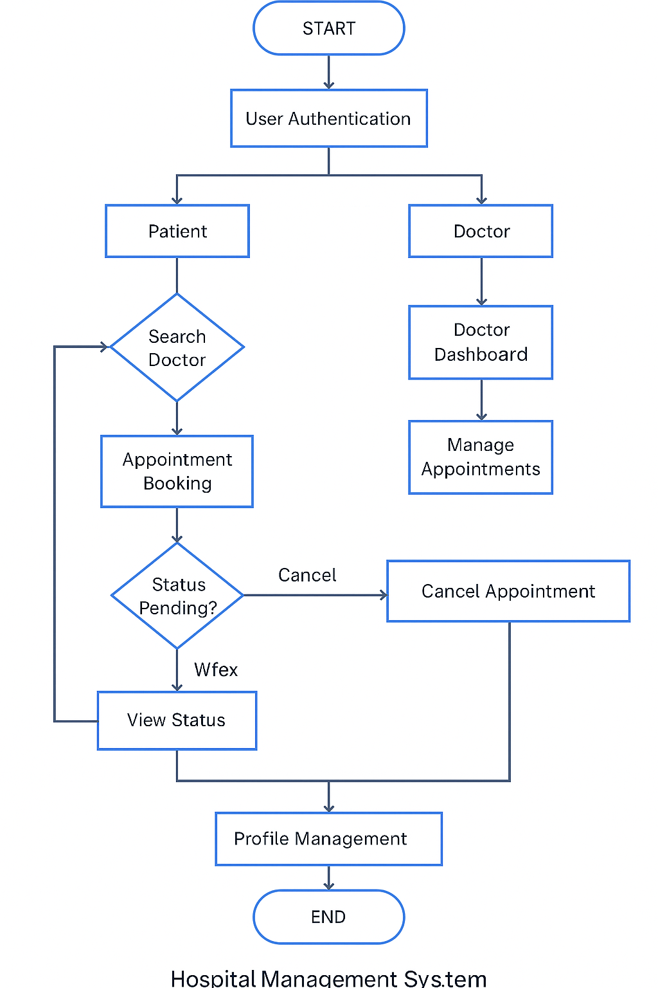

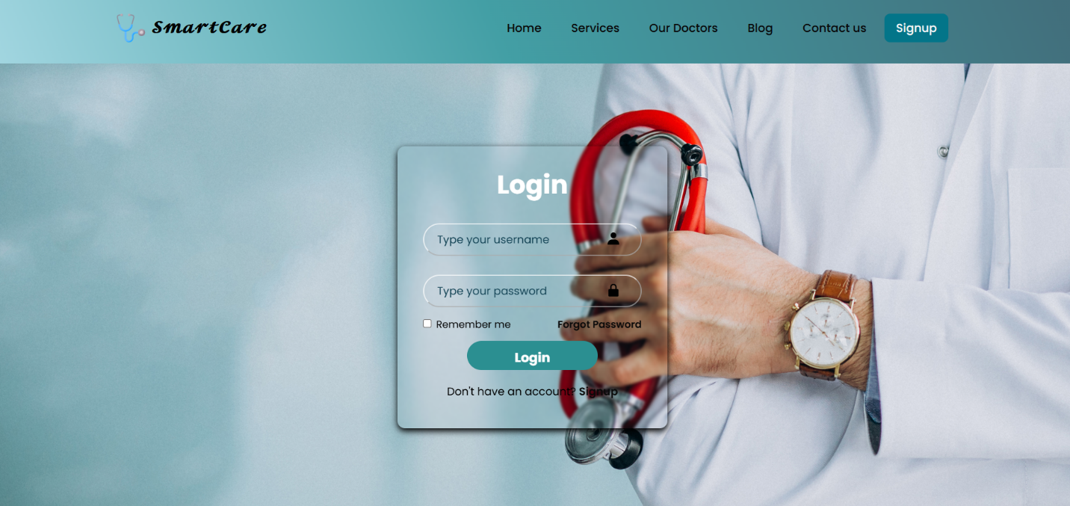

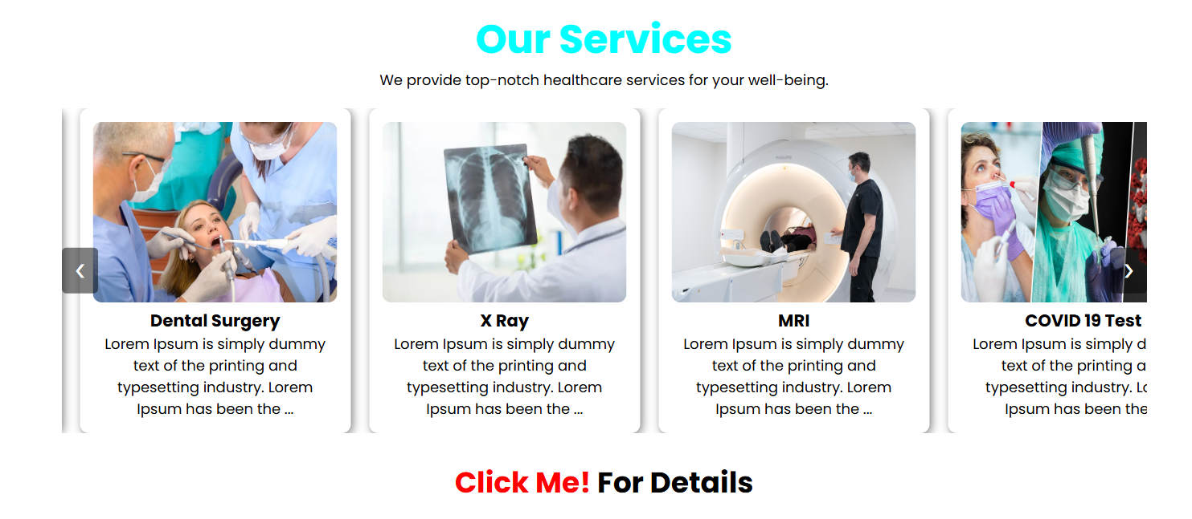

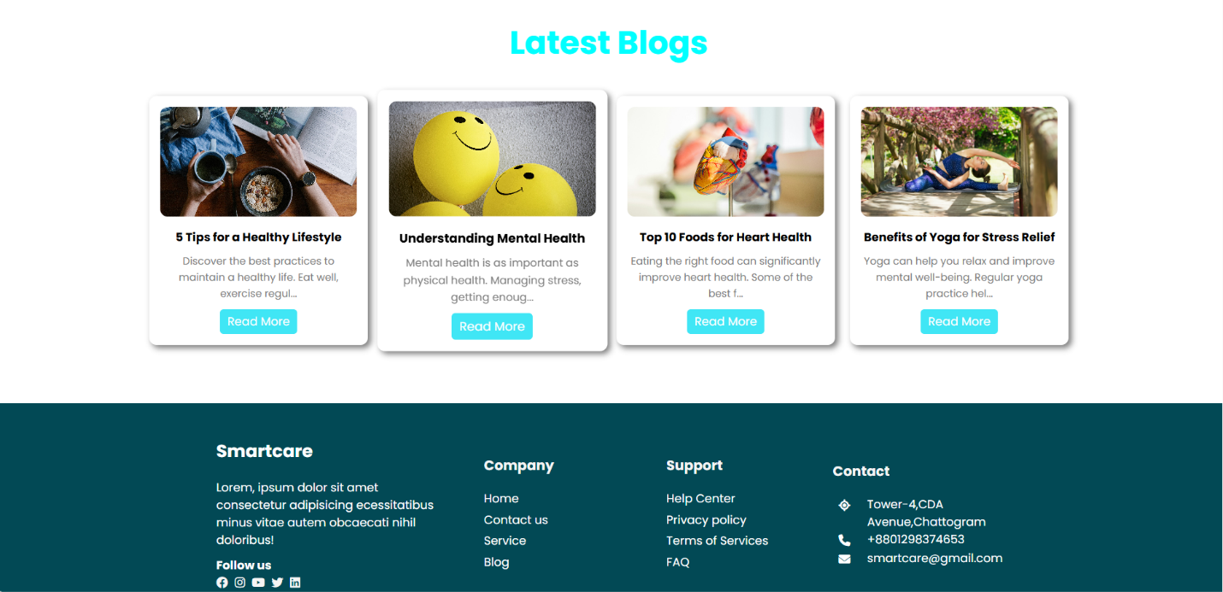

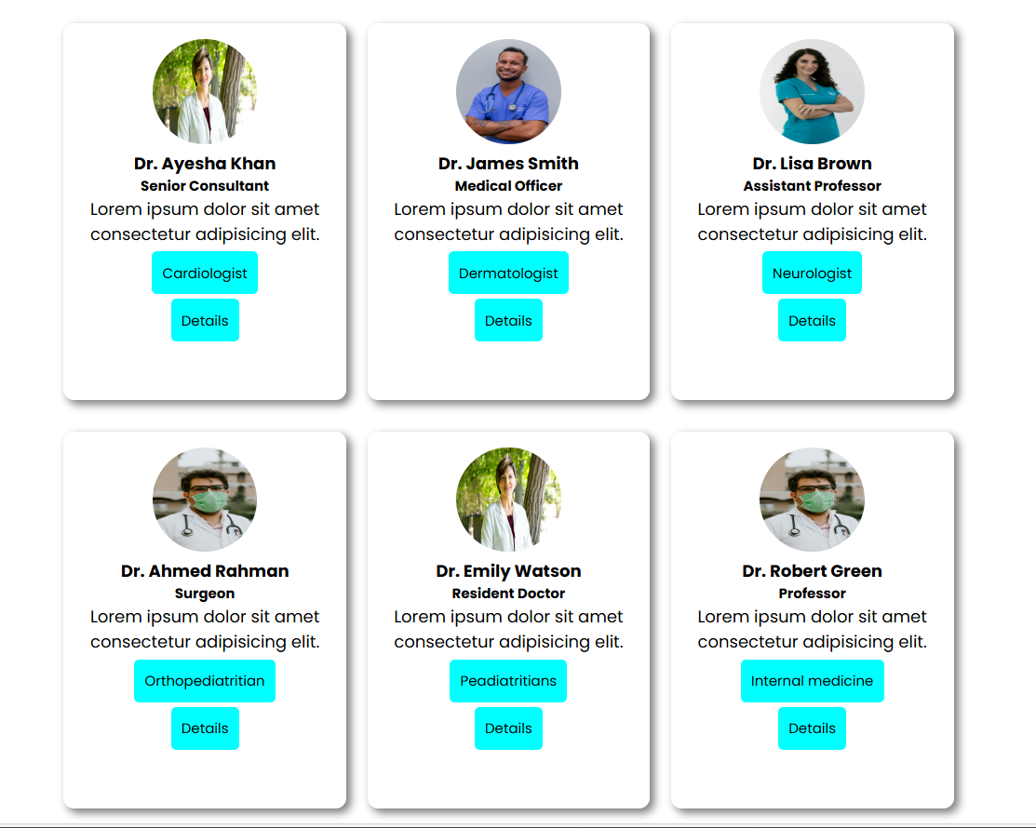

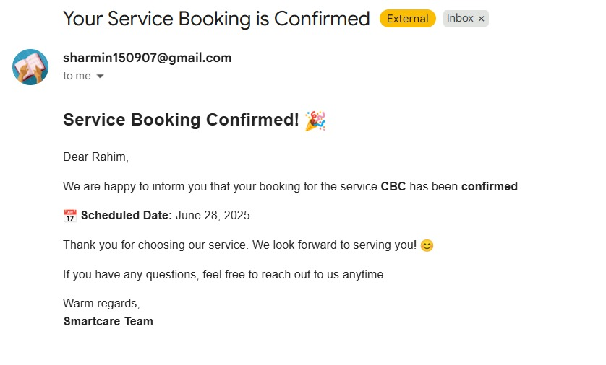

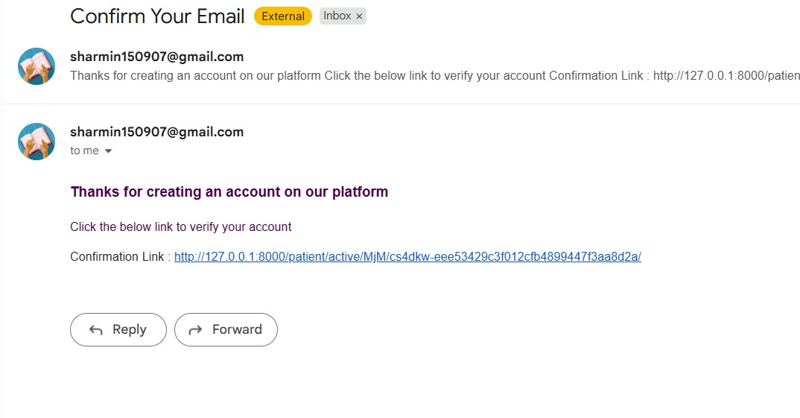

**Conclusion**

The Hospital Management System makes appointment booking and doctor-patient communication easier and more efficient. It helps improve hospital workflow through a secure, automated, and user-friendly platform.